Homework 4 & 5

Today, we have the great pleasure of using clustering and decision trees to solve the historic mystery the Federalist Papers. These papers include a series of 85 documents to encourage the citizens of New York to ratify the US Constitution. Although those documents were signed under the pin name “Publius”, the actual authors of Federalist Papers were Alexander Hamilton, James Madison, and John Jay. It has been documented that 52 of those essays were written by Hamilton, 15 by Madison, and 3 by Jay. Who wrote the remaining 11? It is claimed that either Hamilton or Madison wrote them. We will discover the true author in this project.

**Packages & Libraries**

install.packages("RColorBrewer")

install.packages("NLP")

install.packages("tm")

install.packages("proxy")

install.packages("dplyr")

install.packages("mclust")

install.packages("factoextra")

install.packages("tibble")

install.packages("fancyRpartPlot")

install.packages("rpart")

install.packages("rplot")

install.packages("rpart.plot")

install.packages("rattle")

library(RColorBrewer)

library(wordcloud)

library(slam)

library(quanteda)

library(SnowballC)

library(arules)

library(cluster)

library(stringi)

library(Matrix)

library(tidytext)

library(dplyr)

library(ggplot2)

library(mclust)

library(proxy)

library(tibble)

library(rpart)

library(rpart.plot)

library(rattle)

**Load Data**

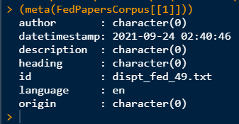

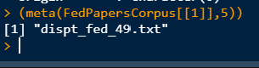

**Data Cleaning**

Now, we will investigate the data and vectorize it using DocumentTermMatrix. We will ignore words and very frequents. This process will perform much of the cleansing process.

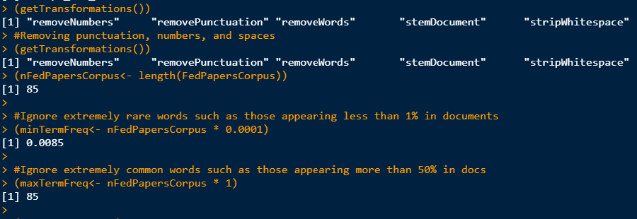

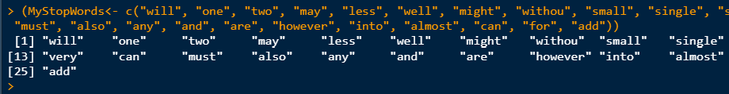

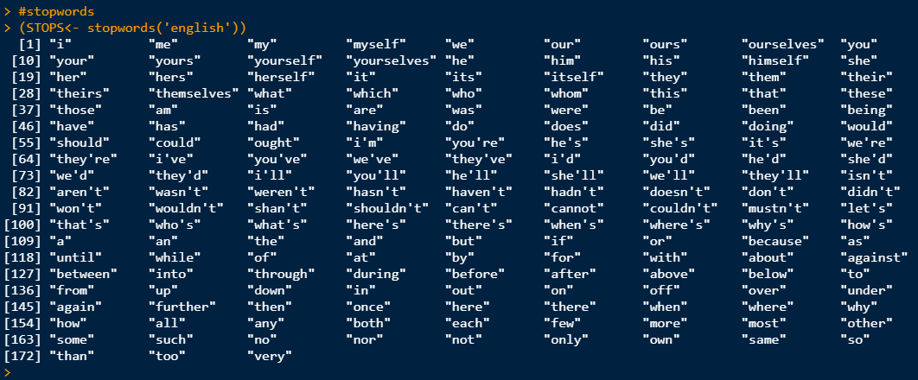

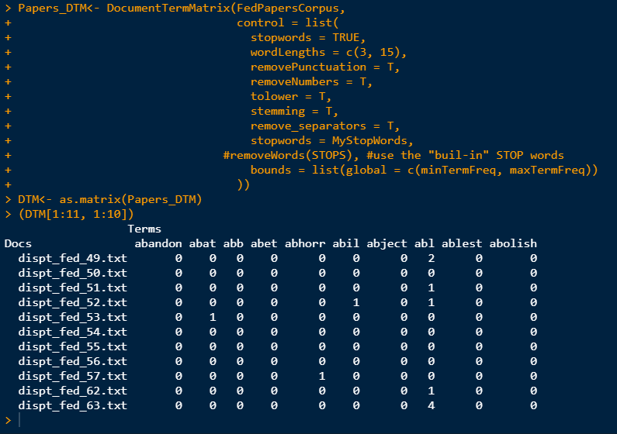

**Inspect Initial Cleaning Results**

Here, we will investigate the initial results of data cleaning. Depending on the results, we may decide to do further cleaning (perhaps add more stop words).

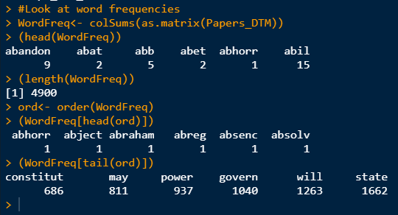

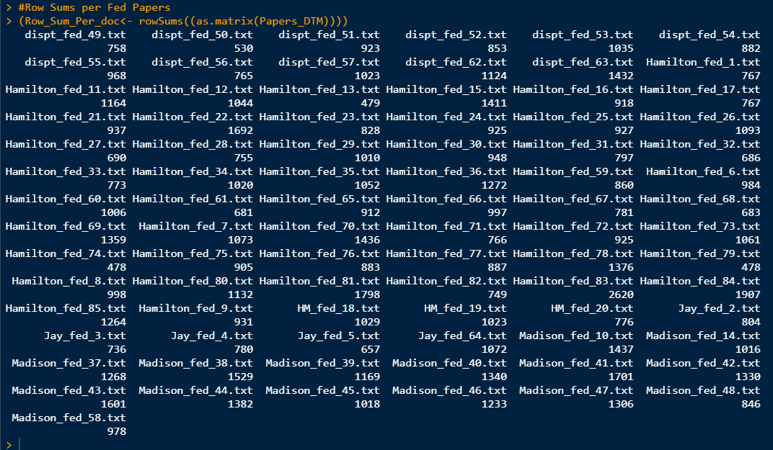

**Normalization**

When processing text data, it is often beneficial to normalize word vectors prior to applying standard analysis techniques.

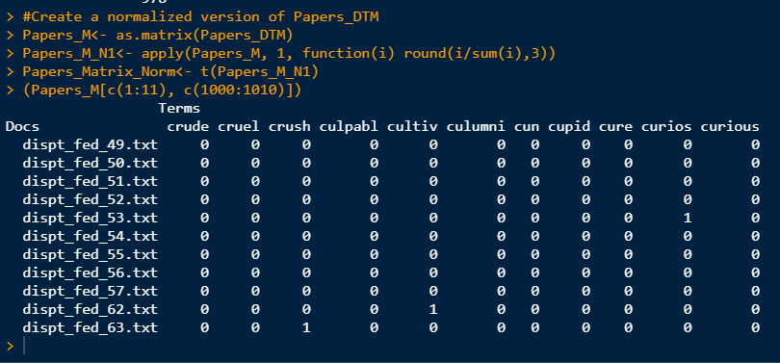

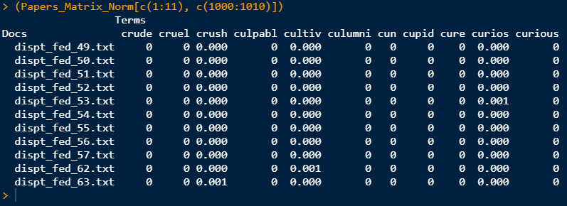

From the line of code '(Row_Sum_Per_doc<- rowSums((as.matrix(FedPapersDTM)))) above, we can see that dispt_fed_text_53/txt has a row sum of 1035. So, we can confirm correctness. For word "curious" we should have 1/1034 = 0.001 rounded, which is what we have.

**Data Structures**

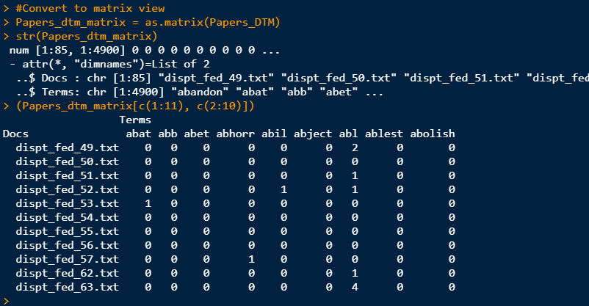

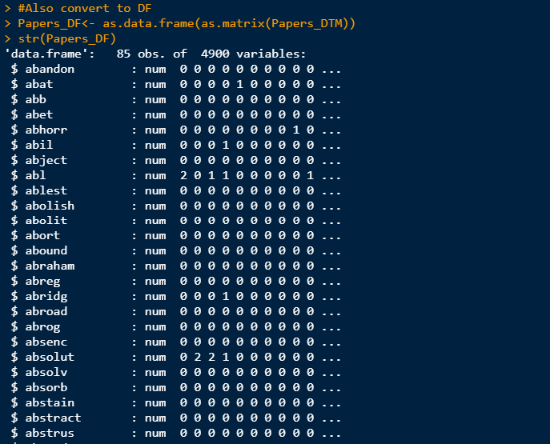

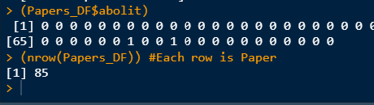

**Word Cloud Example**



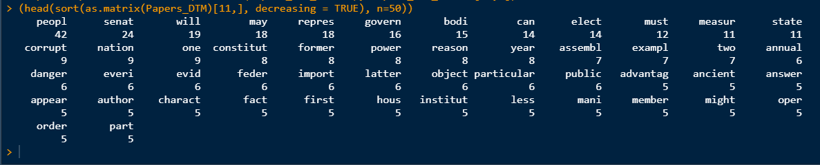



**Analysis**

**.**

Now that the data has been vectorized, analysis can take place. We will apply some distance metrics and see how the data clusters. Note: Cosine distance usually works well with high dimensional data

Distance Metrics

Clustering

Below are some Hierarchical Algorithm Clustering results.



The HAC Cosine Similarity Algorithm works the best. It clusters most of the disputed articles with Madison.



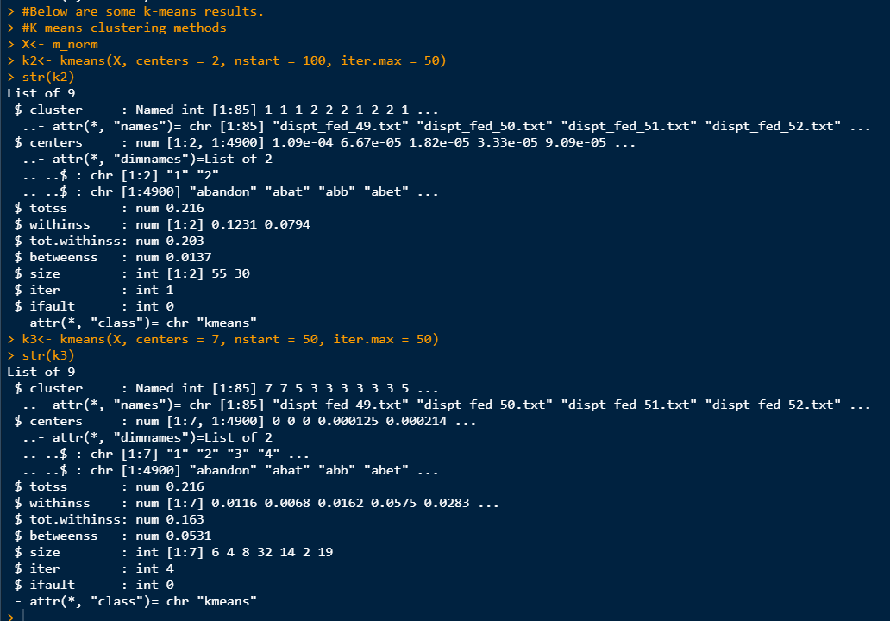

**K-Means Visualization Results**



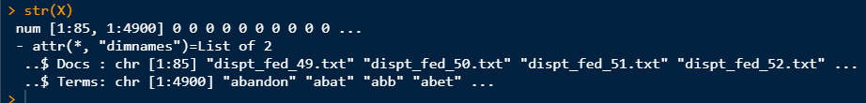

K-Means



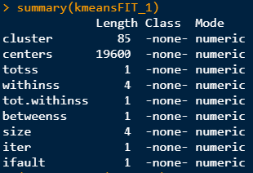



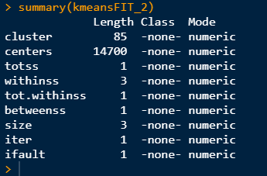

**Label the Data**

Below we label the data, prepare for modeling, and create some wordclouds.

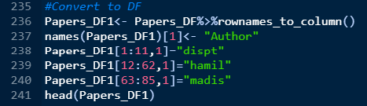

Wordcloud Visualization Hamilton, Madison, and Disputed Papers

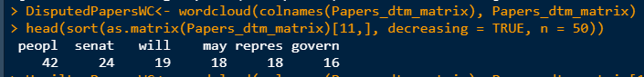

**Experimental Design**

In this section, we will design an experiment. Initially, we randomly select a train and test set for validation.

**Classification**

We are now ready to train and test using classifiers. Below we use a few different decision tree models.

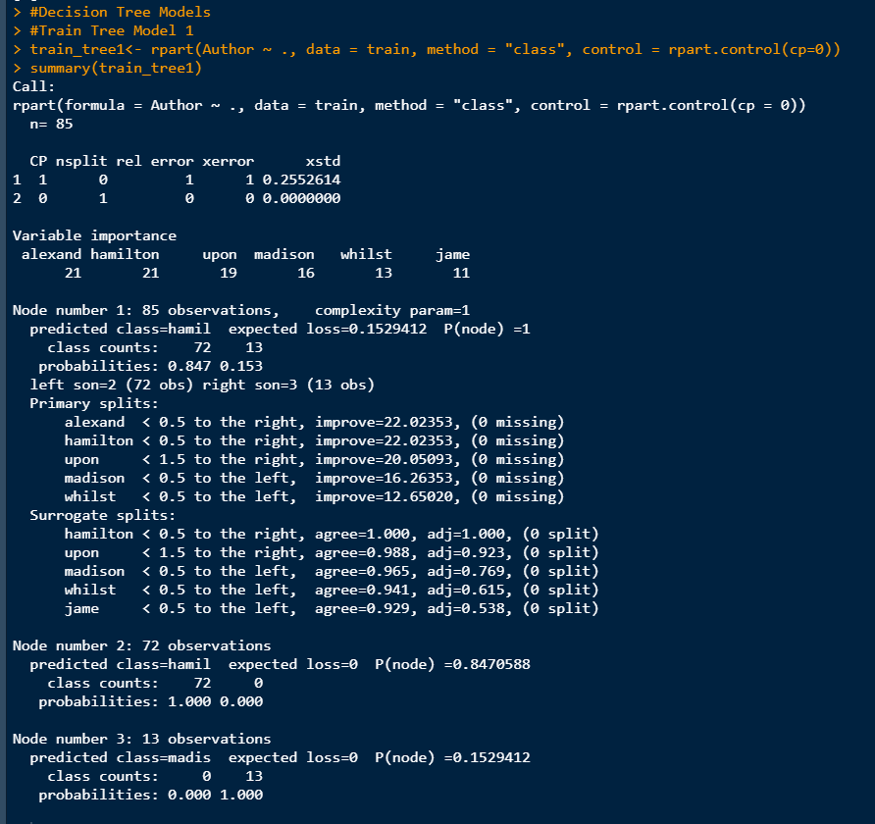

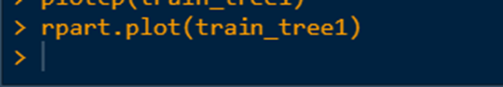

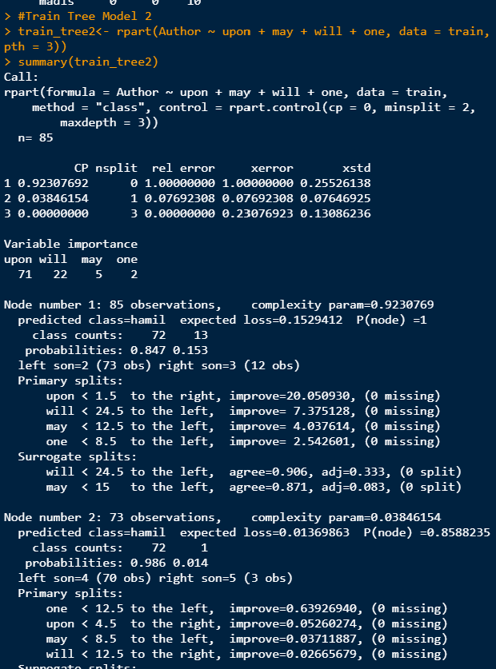

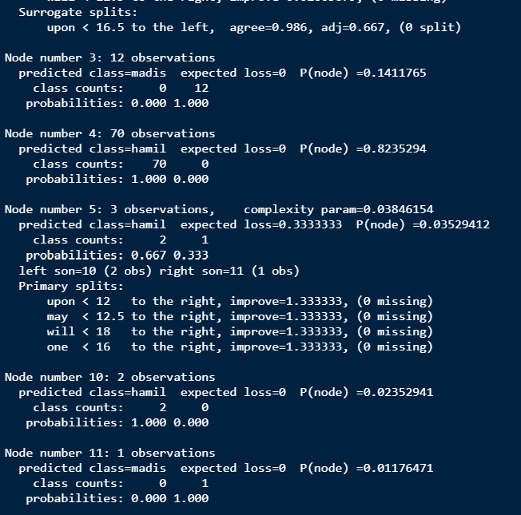

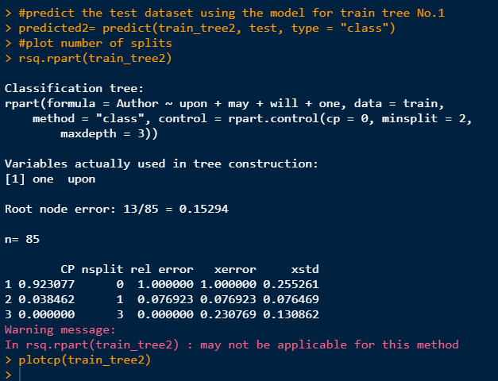

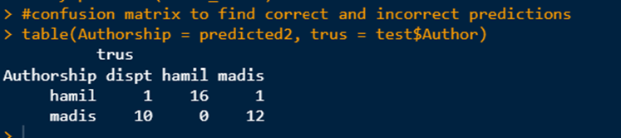

**Conclusion**

Per HAC clustering and decision trees, Madison was the author of the disputed documents of the Federalist Papers.